Contestant Number: ____________________
Time: ___________________
Rank: _______________



FUNDAMENTAL SPREADSHEET APPLICATIONS
(230)

NATIONAL 2021

Production:
Job 1: Create Spreadsheet with Formulas __________ (200 points)
Job 2: Format Spreadsheet __________ (130 points)
Job 3: Create Stacked Area Chart __________ (50 points)
TOTAL POINTS __________ (380 points)

Test Time: 90 minutes

GENERAL GUIDELINES:
Failure to adhere to any of the following rules will result in disqualification:
- Contestant must hand in this test booklet and all printouts if any. Failure to do so will result in disqualification.
- No equipment, supplies, or materials other than those specified for this event are allowed in the testing area. No previous BPA tests and/or sample tests (handwritten, photocopied, or keyed) are allowed in the testing area.
- Electronic devices will be monitored according to ACT standards.

GENERAL INSTRUCTIONS:
- Put your contestant number and printout number in the right section of the footer on each printout unless instructed otherwise. Your name or initials should NOT appear on any work you submit.
- If you finish before the end of the testing time, notify the proctor. Time may be a factor in determining the winner in the event of a tie.
- When turning in your contest, the jobs should be arranged in printout order.

Scenario
You are a scout for the BPA City baseball team. “Go Mavens”! You just finished watching the tryouts and are now looking over the stats to give the coach the best two picks from the 10 that tried out. You are scouting out for two new catchers for the team, so have to give the coach two names. You are creating a spreadsheet to give each player a rating based on his or her defensive drill stats. The two with the highest total rating will be the players you pick.

Job 1 (Worksheet with formulas) | Points Possible | Points Earned
Contestant # and Job # in right section of footer | 10
11 pt. Times New Roman font used for data | 10
Created in landscape orientation | 5
Information on the first 6 catchers entered into the spreadsheet | 10
CSV file: 3 new catchers file in cell H1 (catchers 7-10) | 10
B5 a function entered to total the number of baseballs blocked or went past the catcher | 10
Formula filled from B5 to K5 | 10
B12 a function entered that totals the number of baseball signs the catcher missed & received | 10
Formula filled from B12 through K12 | 10
B7 a formula that calculates the percentage of blocked balls to the total | 10
Fill this formula through to K7 | 10
In cell B8 place a function that calculates a rating based on the following breakdown:  - If >98.5 = 4  - If >97.5 = 3  - If > 96.5 = 2  - If >95.5 = 1  - If<95.5 = 0 | 15
Fill this function across to cell K8 | 10
Cell B14, a formula that calculates the received signs the catcher made | 10
Fill this unction across to cell K14
In cell B15 place a function that calculates a rating based on the following breakdown:  - If >98.5 = 4  - If >97.5 = 3  - If > 96.5 = 2  - If >95.5 = 1  - If<95.5 = 0 | 15
Fill this function across to cell K15 | 10
In cell B20 place a formula that will calculates the number of runners thrown out by the catcher. | 10
Fill this formula across to cell K20 | 10
In cell B21 place a function that calculates a rating based on the following breakdown:  - If >50 = 4  - If >20 = 3  - If >15 = 2  - If >10 = 1  - If<5 = 0 | 15
Fill this function across to cell K21 | 10
In cell B24, create a function that totals the three rating scores together using an absolute reference for the rows only. | 10
Fill this function across to cell K24 | 10
Print a copy of the worksheet vertically and horizontally centered in landscape view. The print out should have a page set-up to fit 1 to 1 page. | 5
Print a copy of the worksheet showing the formulas vertically and horizontally centered in landscape view scale to one page. The print out should have a page set-up to fit 1 to 1 page. | 5
Subtotal | 100

Job 2 (Formatted worksheet) | Points Possible | Points Earned
Contestant # and Job # in right section of footer | 10
Cells B1:K1 wrap text and adjust the cell widths to place the catcher number on the second line. | 15
Place a border on the left side from A2 to A21 using style in second column 6th down from top. | 10
Place a border on the left side from B1 to B21 using style in second column 6th down from top. | 10
Place a border on the left side and right side of cells for columns C-J from rows 1 to 21 using style in second column 2nd down from top. | 10
Place a border on the right side from K2 to K21 using style in second column 6th down from top. | 10
Bold A5, A7, A8, A12, A14, A15, A20 and A21. | 5
Center information in all cells from cell B1 to K21 | 10
Format Row 24 with the following information:  - Britannic Bold  - Size 16 | 10
Place a top and bottom border around cells A24 to K24. | 10
Create a conditional formatting on cells B24: K24 of greater than 10, fill with red color and red text. | 15
Format the page setup to fit to one to one page with landscape | 10
Print out the formatted spreadsheet with it centered horizontally and vertically on the page | 5
Subtotal | 130

Job 3 (Stacked Area Chart) | Points Possible | Points Earned
Contestant # and Job # in right section of footer | 10
Chart created using the catcher information and their total ratings | 10
Layout 7 (puts lines in the chart area) | 5
Monochrome color 11 (should still show the lines in the chart area) | 5
Title size 20 font; Britannic Bold | 10
Legend is removed from the chart | 5
Pivot chart and information printed in landscape orientation on one page. | 5
Subtotal | 50
TOTAL POINTS | 380

JOB 1: Create Spreadsheet with Formulas
- Enter the following data into an Excel spreadsheet like shown below and complete the calculations as instructed. Use Times New Roman size 11 font and landscape orientation.

- In cell H1, import the CSV delimited file: 4 new catchers file

- In cell B5, place a function that totals the number of baseballs blocked or went past the catcher.

- Fill the formula from B5 through K5.

- In cell B12, create a function that totals the number of baseball signs the catcher missed and received.

- Fill the formula from B12 through K12.

- In cell B7 insert a formula that calculates the percentage of blocked balls to the total.

- Fill this formula across to K7.

- In cell B8 place a function that calculates a rating based on the following breakdown:

- If >98.5 = 4
- If >97.5 = 3
- If > 96.5 = 2
- If >95.5 = 1
- If<95.5 = 0

- Fill this function across to K8.

- In cell B14, insert a formula that calculates the percentage of received signs the catcher made.

- Fill this function across to K14.

- In cell B15, insert a function that calculates a rating based on the following breakdown:

- If >98.5 = 4
- If >97.5 = 3
- If > 96.5 = 2
- If >95.5 = 1
- If<95.5 = 0

- Fill this function across to cell K15.

- In cell B20, place a formula that will calculate the percentage of runners thrown out by the catcher.

- Fill this formula across to cell K20.

- In cell B21, insert a function that calculates a rating based on the following breakdown:

- If >50 = 4
- If >20 = 3
- If > 15 = 2
- If >10 = 1
- If>5 = 0

- Fill this function across to cell K21.

- In cell B24, create a function that totals the three rating scores together using an absolute reference for the rows only.

- Fill the function across to cell K24.

- Print a copy of the worksheet vertically and horizontally centered, in landscape view, and with gridlines. The print out should have a page set-up to fit 1 to 1 page.

- Print a copy of the worksheet showing the formulas vertically and horizontally centered, in landscape view, with gridlines, and custom scale to 75% of normal size. (you will have multiple printouts)

JOB 2: Format the Spreadsheet you created in Job 1 using the following instructions:

- Cells B1:K1 wrap text and adjust the cell widths to place the catcher number on the second line.

- Place a border on the left side from A2 to A21 using border style in the second column 6th down from top.

- Place a border on the left side from B1 to B21 using border style in the second column 6th down from top.

- Place a border on the left side and right side of cells for columns C-J from rows 1 to 21 using border style in the second column 2nd down from top.

- Place a border on the right side from K2 to K21 using border style in the second column 6th down from top.

- Bold A5, A7, A8, A12, A14, A15, A20 and A21.

- Center information in all cells from cell B1 to K21.

- Format Row 24 with the following information:
- Britannic Bold
- Size 16
- Place the “top and bottom border” style around cells A24 to K24.

- Create a conditional formatting on cells B24: K24 of greater than 10. Format the results with a fill color of red and red text.

- Format the worksheet with a page setup of a fit to one page and landscape.
- Print out the formatted spreadsheet with it centered horizontally and vertically on one page.
JOB 3: Create a Stacked Area Chart
Create a Stacked Area chart from the spreadsheet you have created in the previous jobs showing the catchers and their rating. Create and move to its own sheet. Change the sheet name to Total Ratings Chart.
Format the chart to look like the following:
- Layout 7.
- Change to monochrome color 11.
- Change title font style to Britannic Bold, size 20 font.
- Remove the legend from the chart.
- Print out on full sheet in landscape orientation on one page.

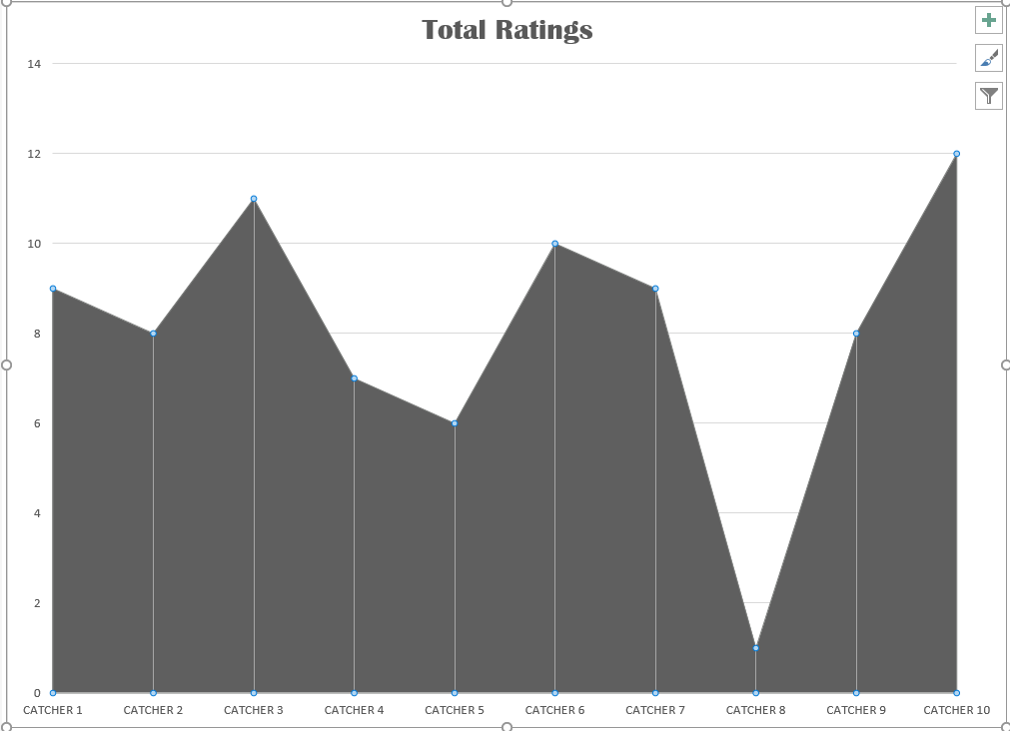

You should have the following four printouts:
Job 1—Unformatted
Job 1—Formulas
Job 2—Formatted
Job 3—Stacked Area Chart

